Deploy and roll back

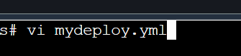

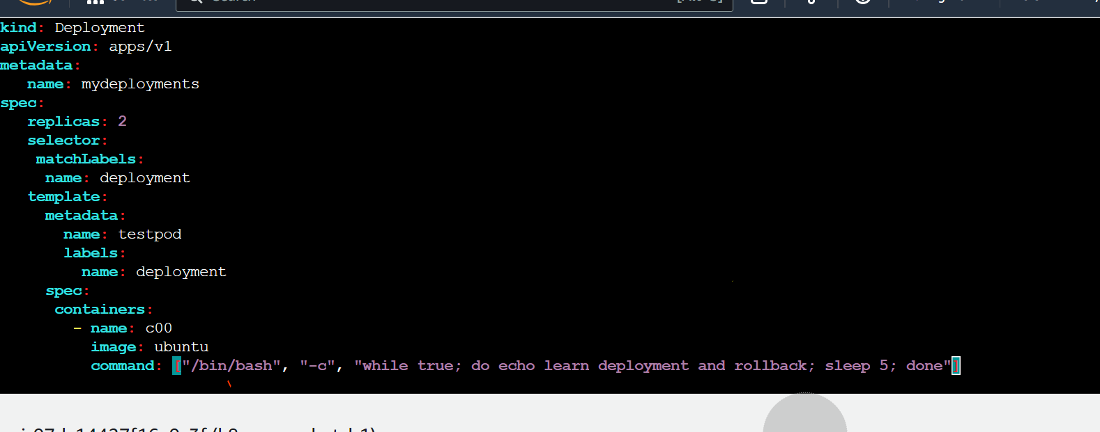

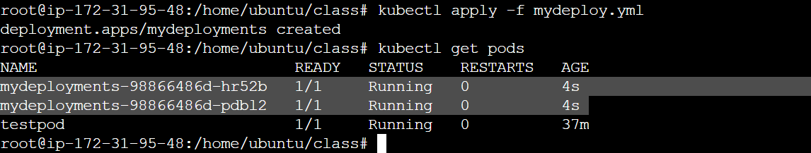

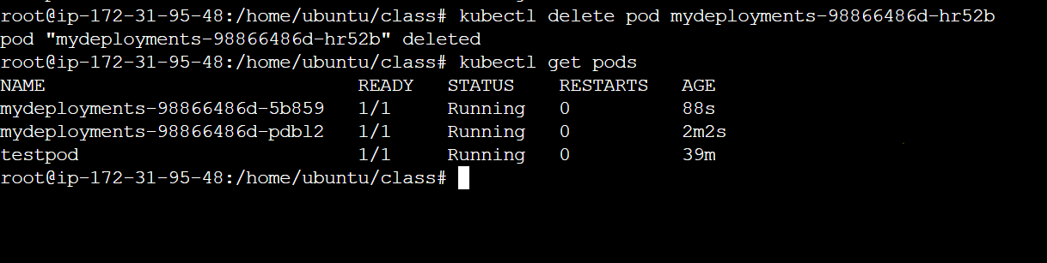

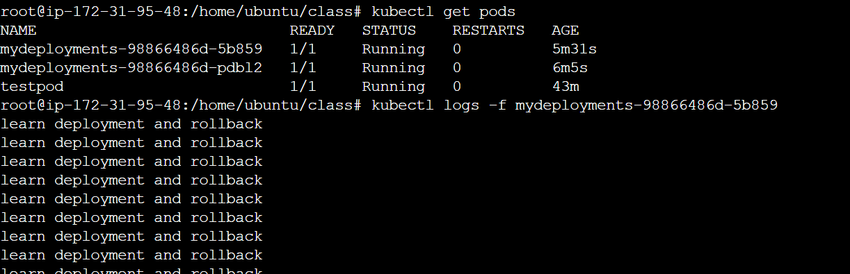

(press ctrl c to come out)

Lets now create a new replica with the same deployment (version2 of app)

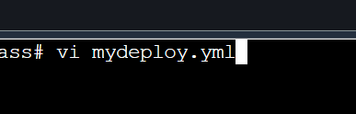

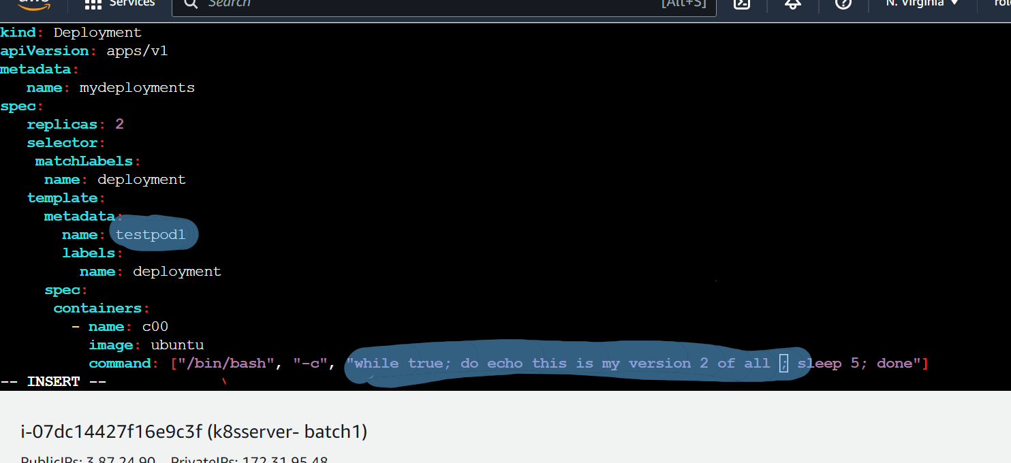

(don’t retype the code…just make the changes at highlighted area)

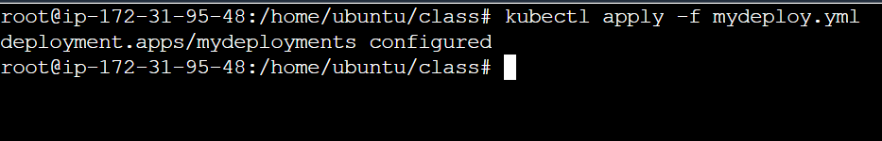

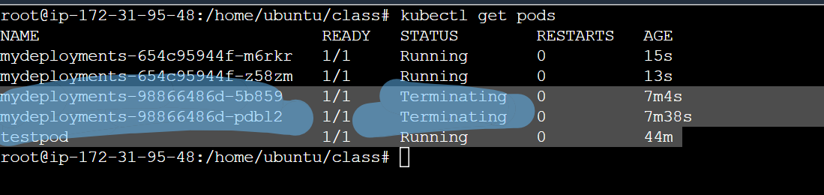

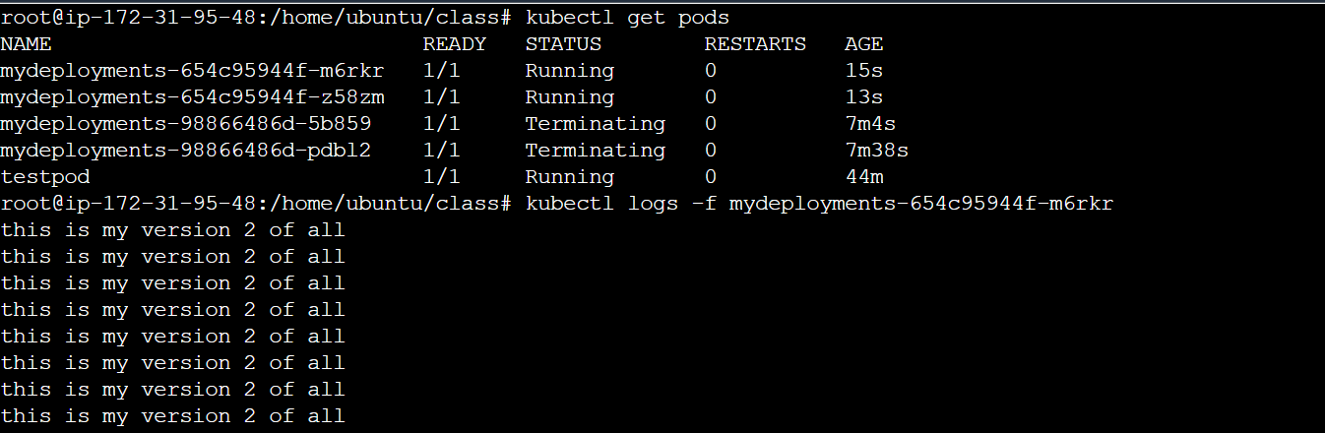

## ROLL BACK : lets suppose that the latest version have some issues….then we can even move to the old version



